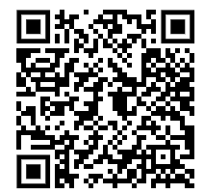Sven Pajač:

Mary Brown

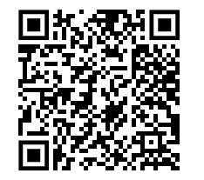

Danijel Papić:

Alice Parker

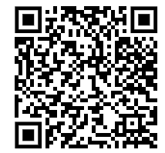

Nika Čerenšek:

Nancy Johnson

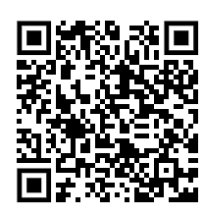

Zejneb Hasanović:

Letitia Geer

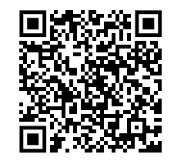Sven Čaušević:

Dr. Maria Telkes

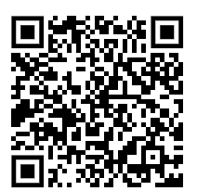Marvin Nazifović Zrno:

Hedy Lamar

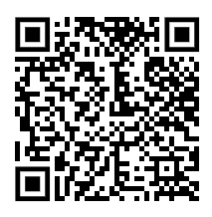

Alen Vodopija:

Anne Connely

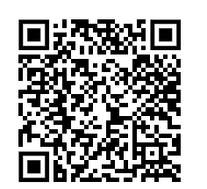

Ana Alanović:

Dr . Grace Murry Hopper

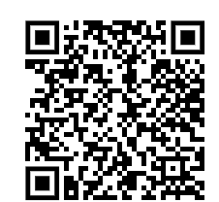

Bela Cerić:

Dr. Shirley Jackson

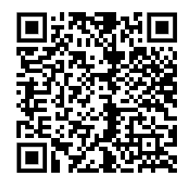

Sven Davidović:

Florence Parpart

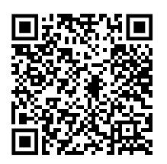

Kulsum Mandžić:

Elizabeth Maggie

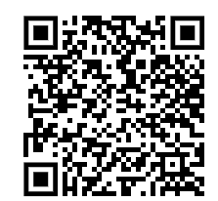

Lola Omazić:

Margaret Knight

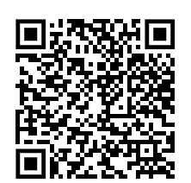

Luka Košćal:

Margaret Wilcox

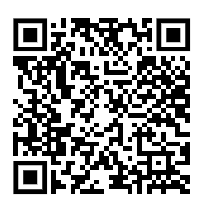

Antun Mamić:

Stephanie Knowlek

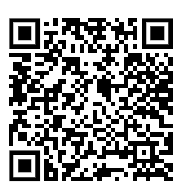

Toni Šprem:

Josephine Chochraine

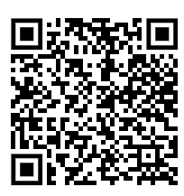

Niko Lončar:

Maria Baesely